COMPILER PHASE VISUALIZER
Technical Project Documentation

TEAM MEMBERS:
1.Magesh kumar (684)
2.Nishanth (696)
3.Sanjai Guru (698)
4.Euvan (700)
1. Introduction
The Compiler Phase Visualizer is designed to demonstrate the internal working of a compiler in a clear and interactive manner. It accepts a C program as input and processes it through all six classical compiler phases, displaying the output of each phase step-by-step.
This project is primarily developed as an educational tool for students and developers to understand how high-level source code is translated into low-level machine-like instructions.

2. Objective
The main objectives of this project are:
- To visualize each phase of a compiler in a structured manner
- To help students understand compiler design concepts practically
- To provide an interactive interface for learning
- To simulate real compiler behavior using simplified logic

3. System Overview
The consists of three main components:
3.1 Frontend
- Built using React and Tailwind CSS
- Provides user interface for code input and output visualization
- Displays results for each compiler phase
3.2 Compiler Engine
- Implemented in Vanilla JavaScript
- Located inside a single HTML file
- Handles all six compiler phases
3.3 Backend
- Built using FastAPI (Python)
- Provides API support and health checks
- Stores data in MongoDB
3.4 Database
- MongoDB is used for storing status records and timestamps

4. System Architecture
The system follows a layered architecture:
- Presentation Layer: React frontend
- Processing Layer: JavaScript compiler engine
- Service Layer: FastAPI backend
- Data Layer: MongoDB

5. Working Principle (Data Flow)
The workflow of the system is as follows:
- User enters C code in the input area
- User clicks “Compile & Visualize”
- The compiler engine processes the code through multiple stages
- Each phase generates output
- Results are displayed visually in the interface

6. Compiler Phases
The project implements all six classical compiler phases:
6.1 Lexical Analysis
- Converts source code into tokens
- Tokens include:
  - Keywords (int, if, for, etc.)
  - Identifiers (variable names)
  - Constants (numbers)
  - Operators (+, -, *, etc.)
Output: Token table with type and value
6.2 Syntax Analysis
- Converts tokens into an Abstract Syntax Tree (AST)
- Uses recursive descent parsing
- Ensures grammar correctness
Output: Tree representation of the program
6.3 Semantic Analysis
- Checks meaning of the program
- Performs:
  - Type checking
  - Variable declaration validation
  - Scope resolution
Output: Symbol table and annotated tree
6.4 Intermediate Code Generation (ICG)
- Converts AST into Three Address Code (TAC)
- Uses temporary variables (t1, t2, etc.)
- Includes labels for control flow
Example:
t1 = a + b
if t1 < 10 goto L1
Output: TAC table
6.5 Code Optimization
- Improves intermediate code efficiency
- Techniques used:
  - Constant folding
  - Dead code elimination
Output: Optimized TAC
6.6 Target Code Generation
- Converts optimized code into assembly-like instructions
- Uses registers (R0, R1, etc.)
Example:
MOV R0, a
ADD R1, R0, b
Output: Assembly-like code

7. Features
- Interactive compiler visualization
- Step-by-step execution
- AST graphical representation
- TAC generation (Quadruples, Triples)
- Code optimization comparison
- Assembly code output

8. Backend API
The backend provides the following endpoints:
- GET /api/ → Health check
- POST /api/status → Store status data
- GET /api/status → Retrieve stored data

9. Technology Stack
Category | Technology Used
Frontend | React, Tailwind CSS
Backend | FastAPI (Python)
Database | MongoDB
Compiler Logic | JavaScript
Server | Uvicorn

10. Advantages
- Easy understanding of compiler phases
- Visual learning approach
- No need for external compiler tools
- Suitable for academic learning

13. Conclusion
The Compiler Phase Visualizer successfully demonstrates how a compiler works internally by breaking down the process into six distinct phases. It provides a clear and structured understanding of compilation, making it a valuable educational tool for students and learners.
The project combines frontend, backend, and core compiler logic effectively, making it both technically sound and practically useful.

Test Case 1: Nested For loop

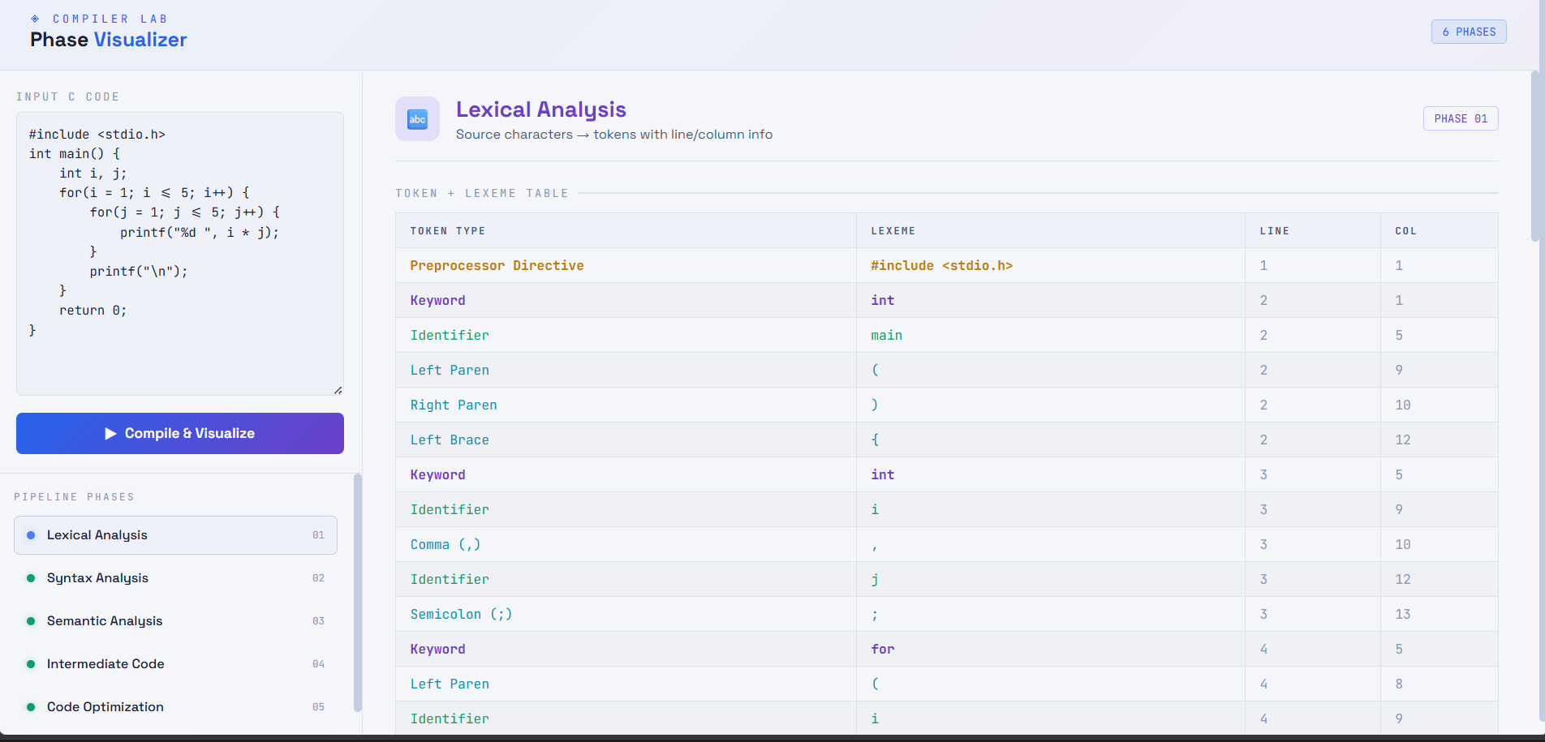

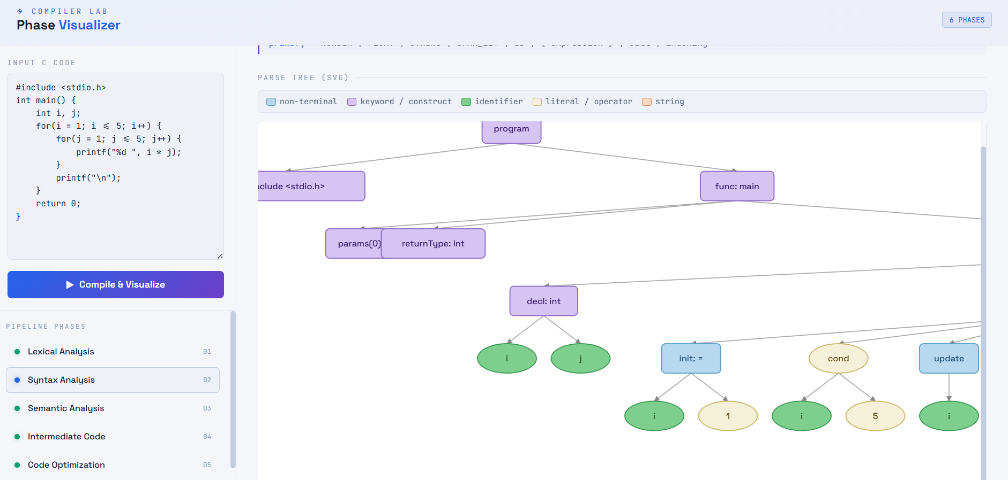

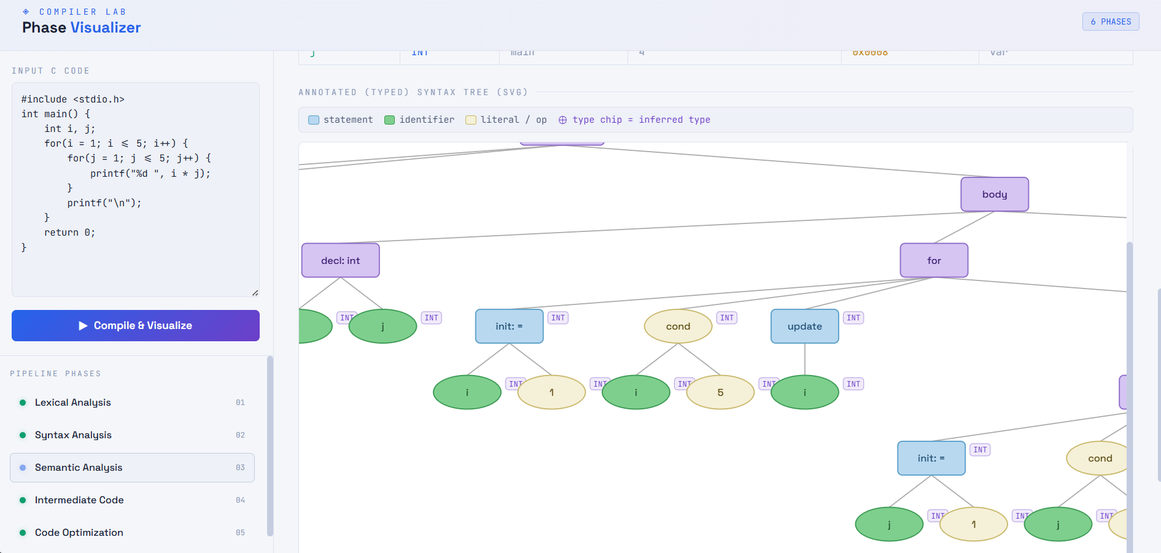

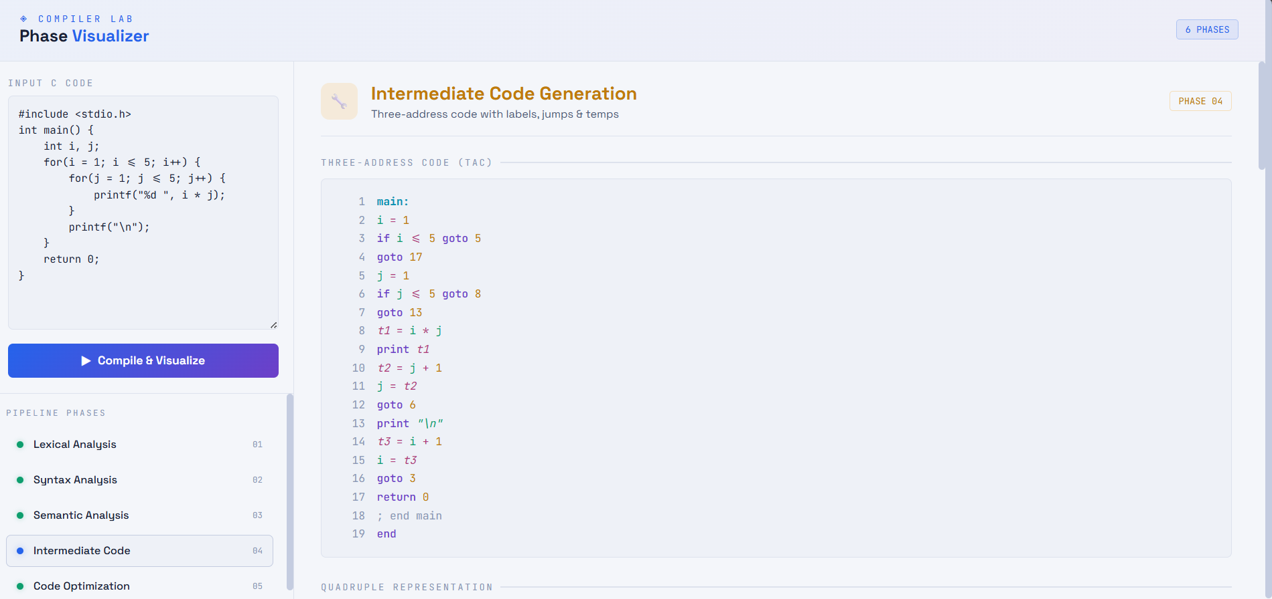

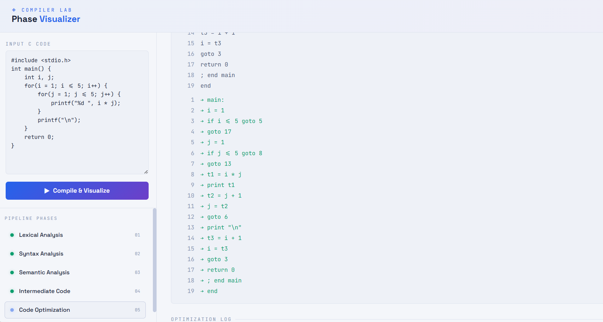

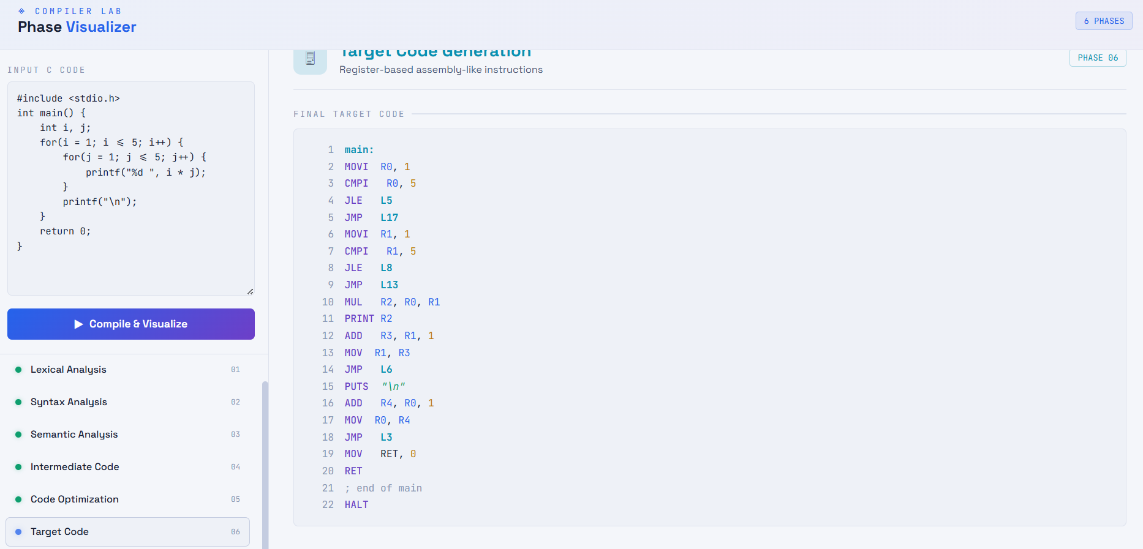

Test Case2: While Loop

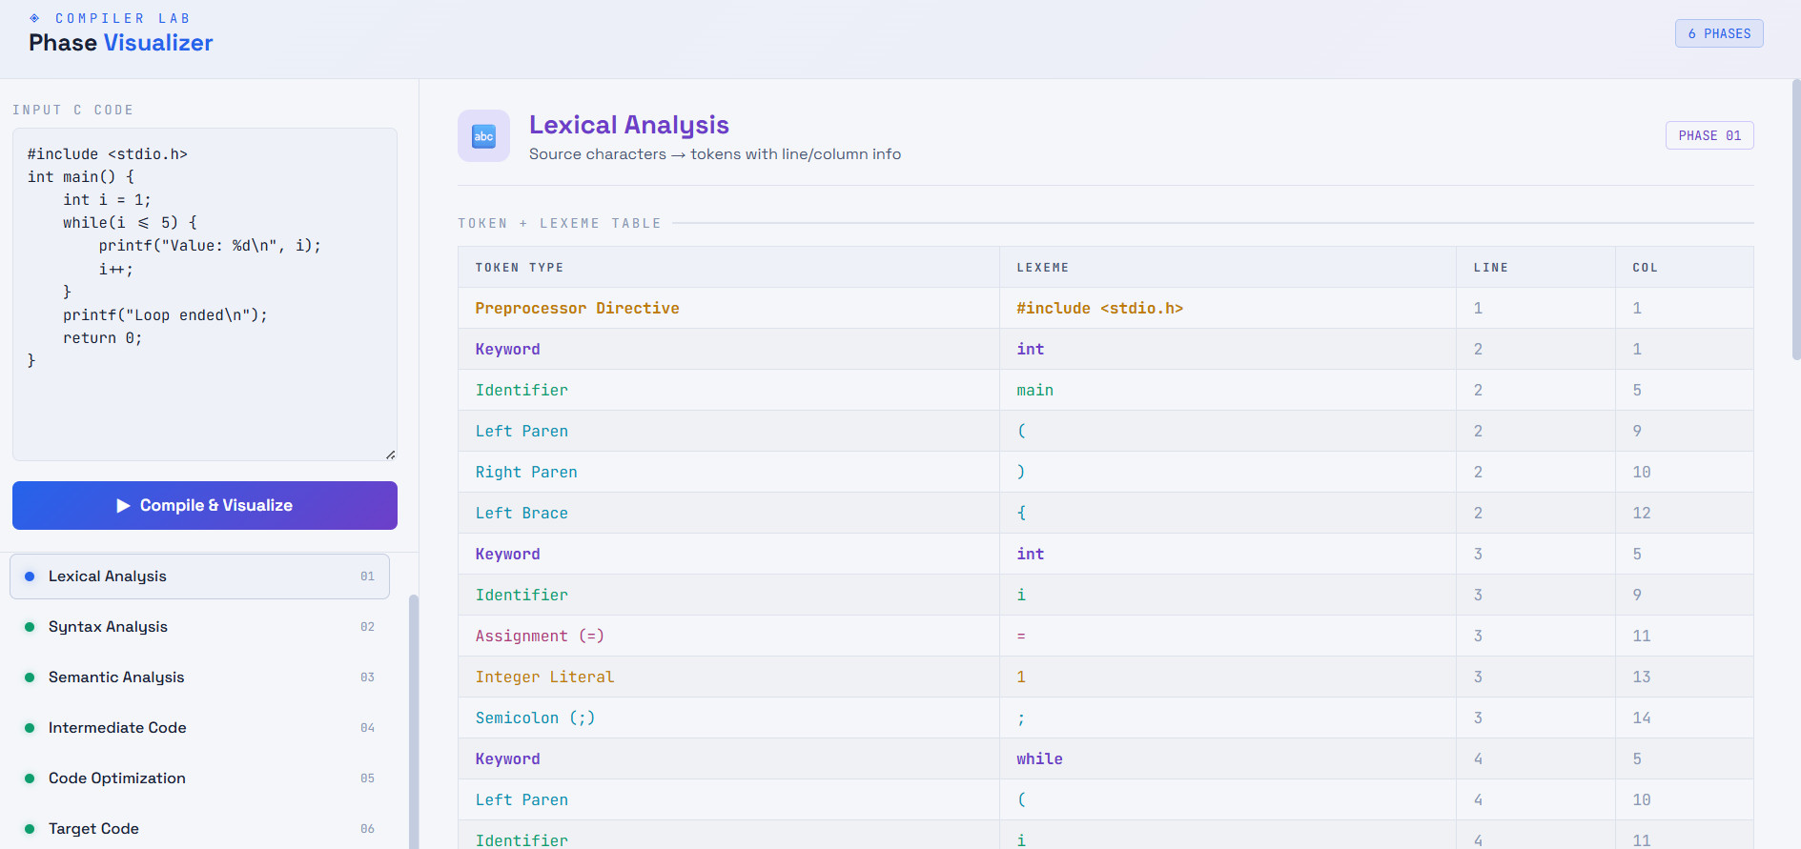

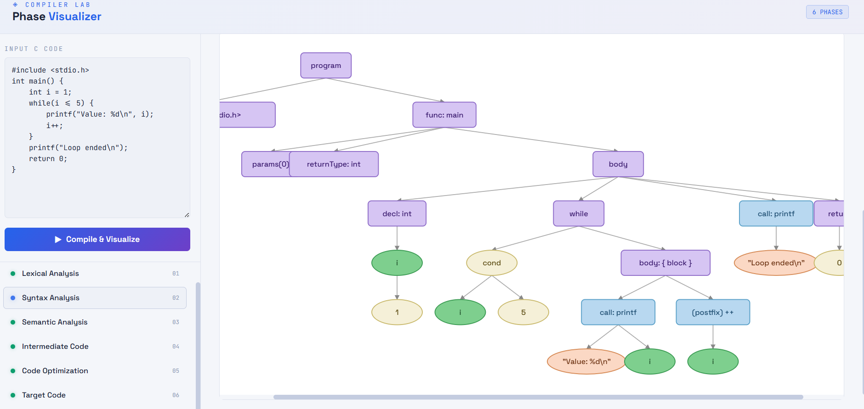

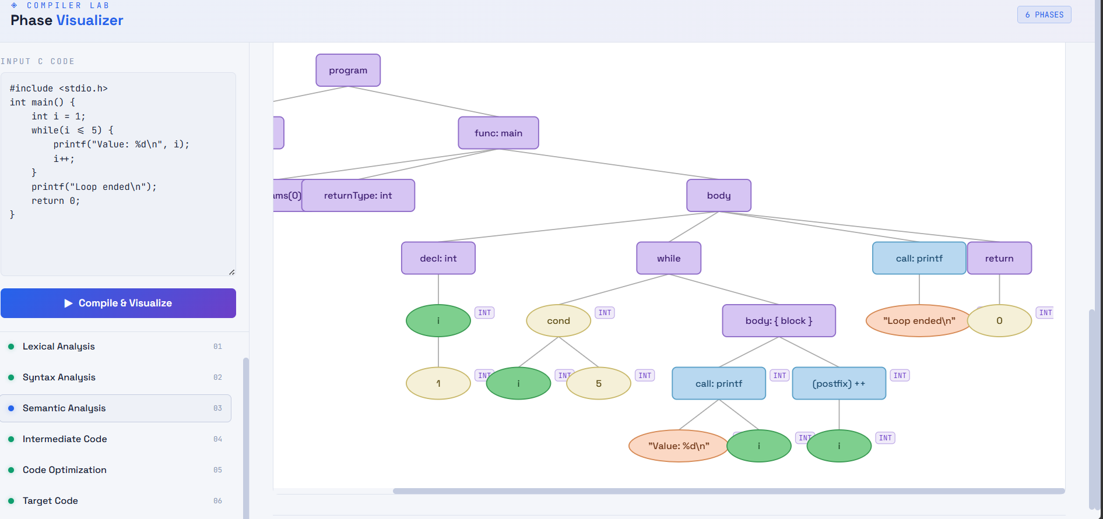

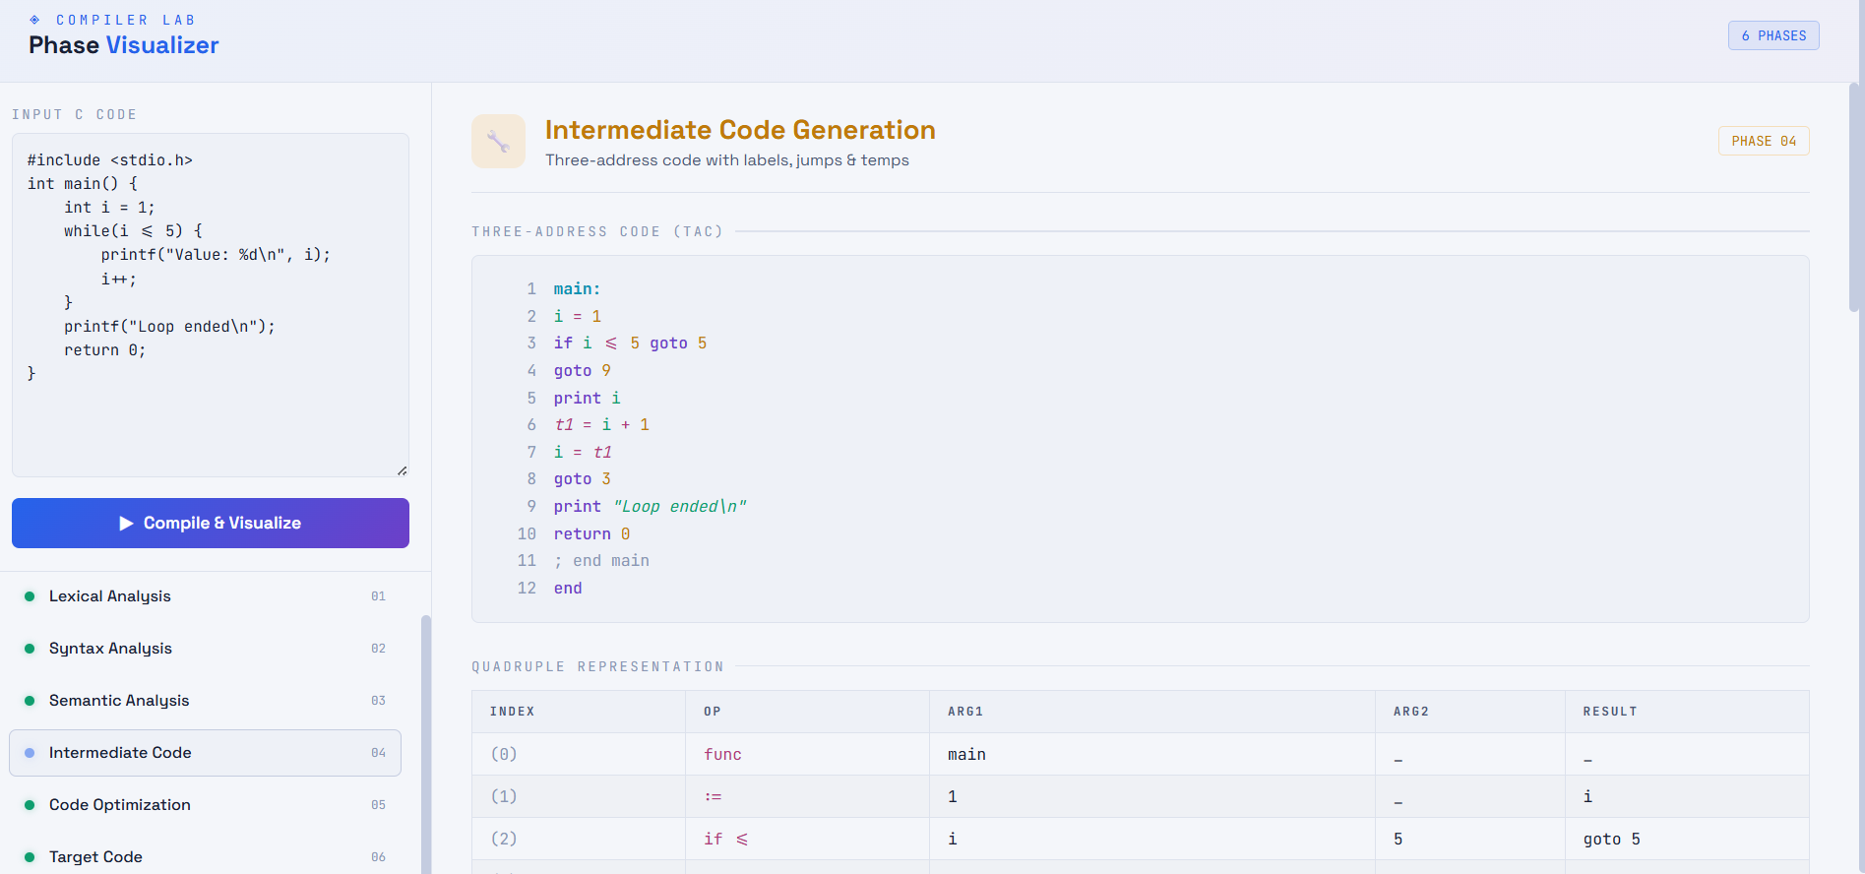

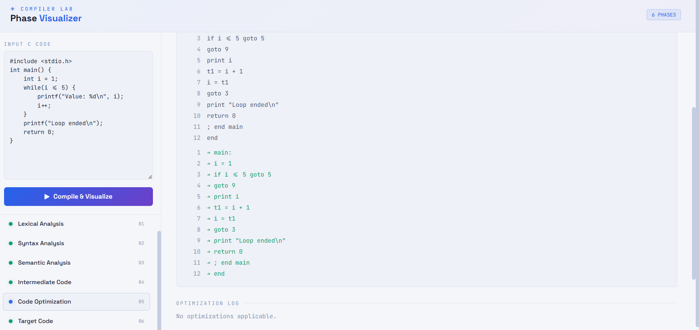

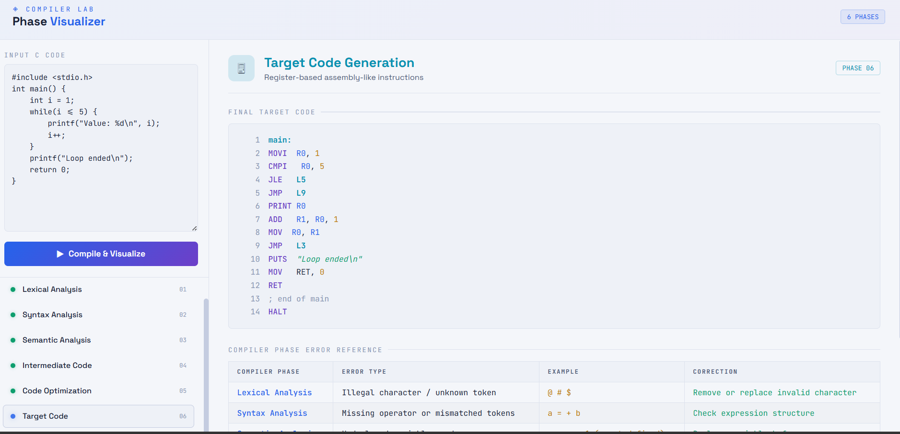

Test Case 3: If else ladder

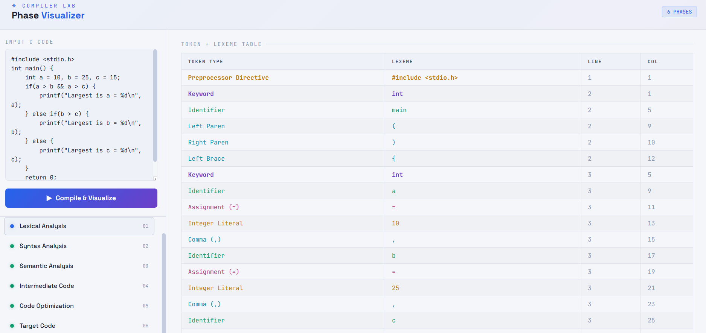

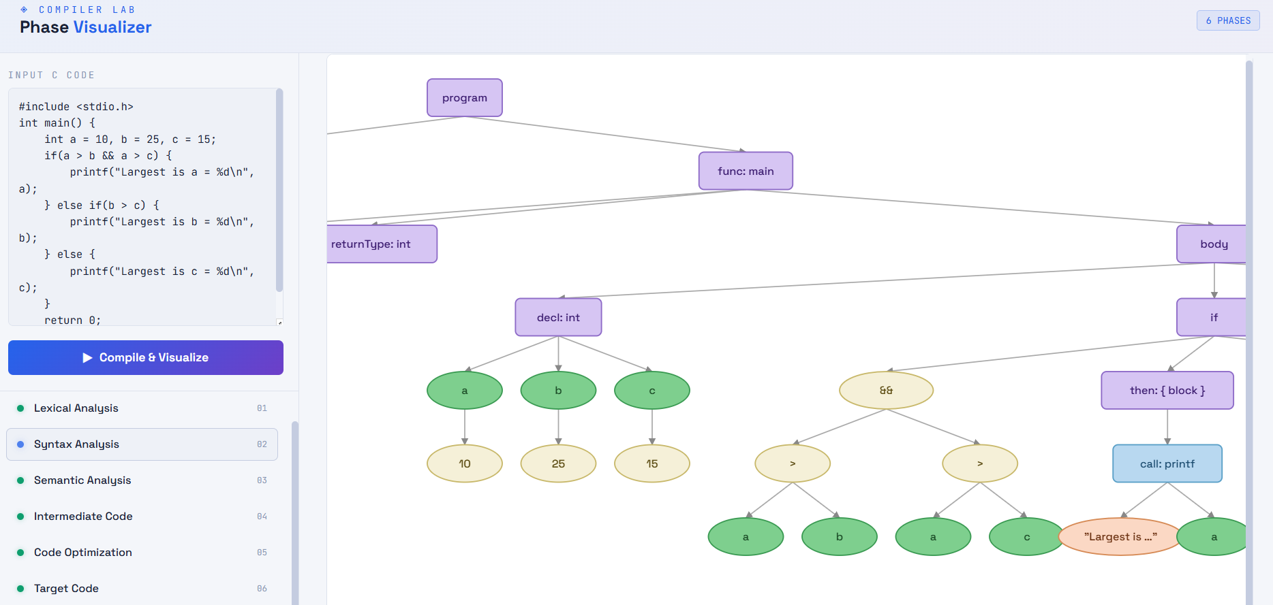

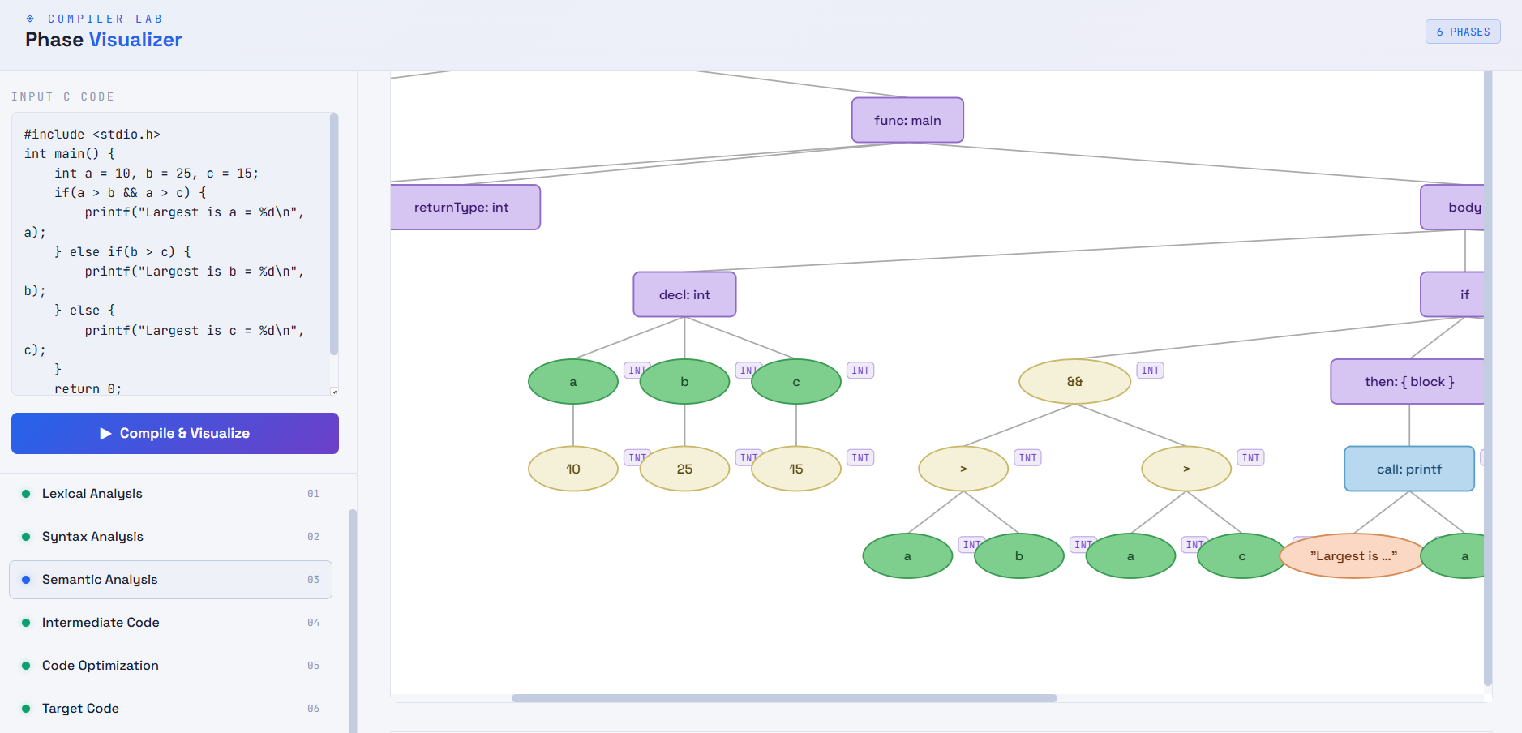

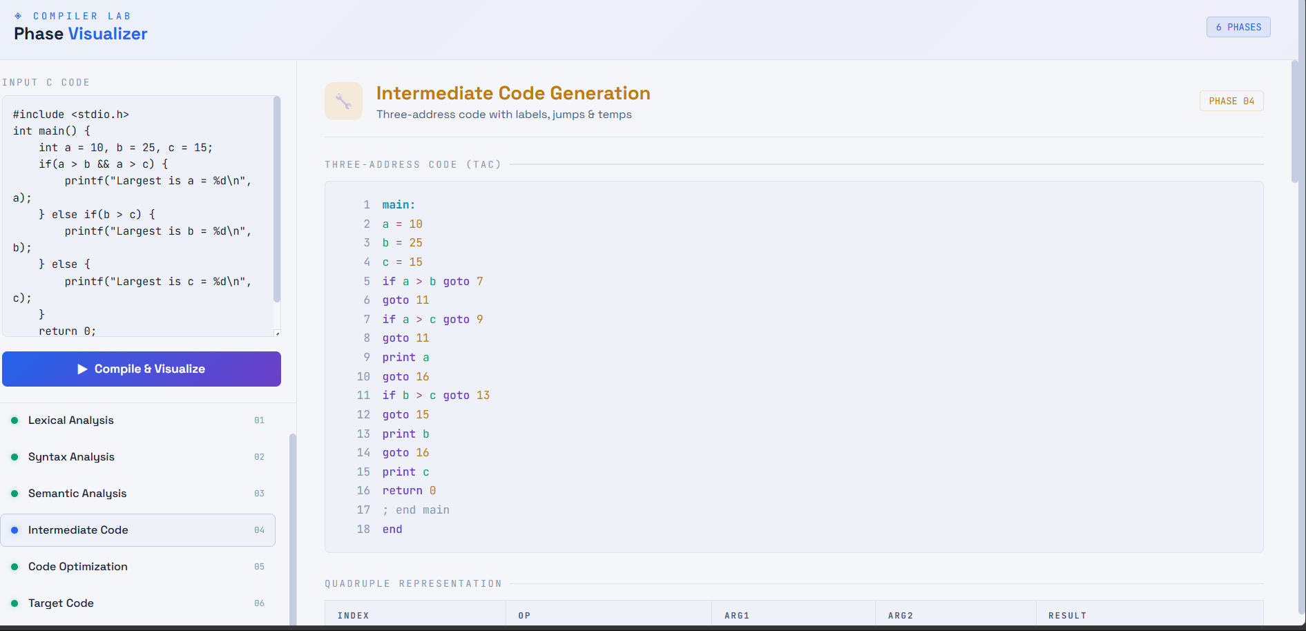

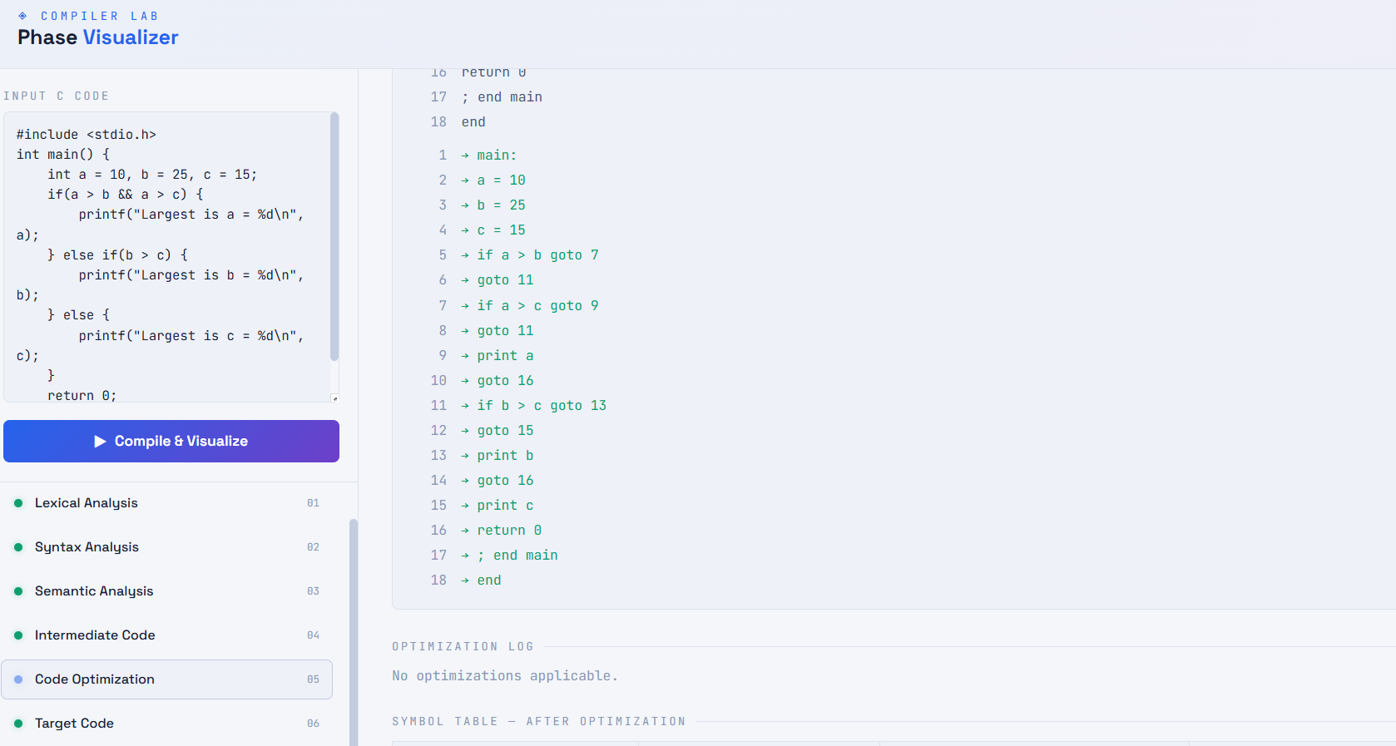

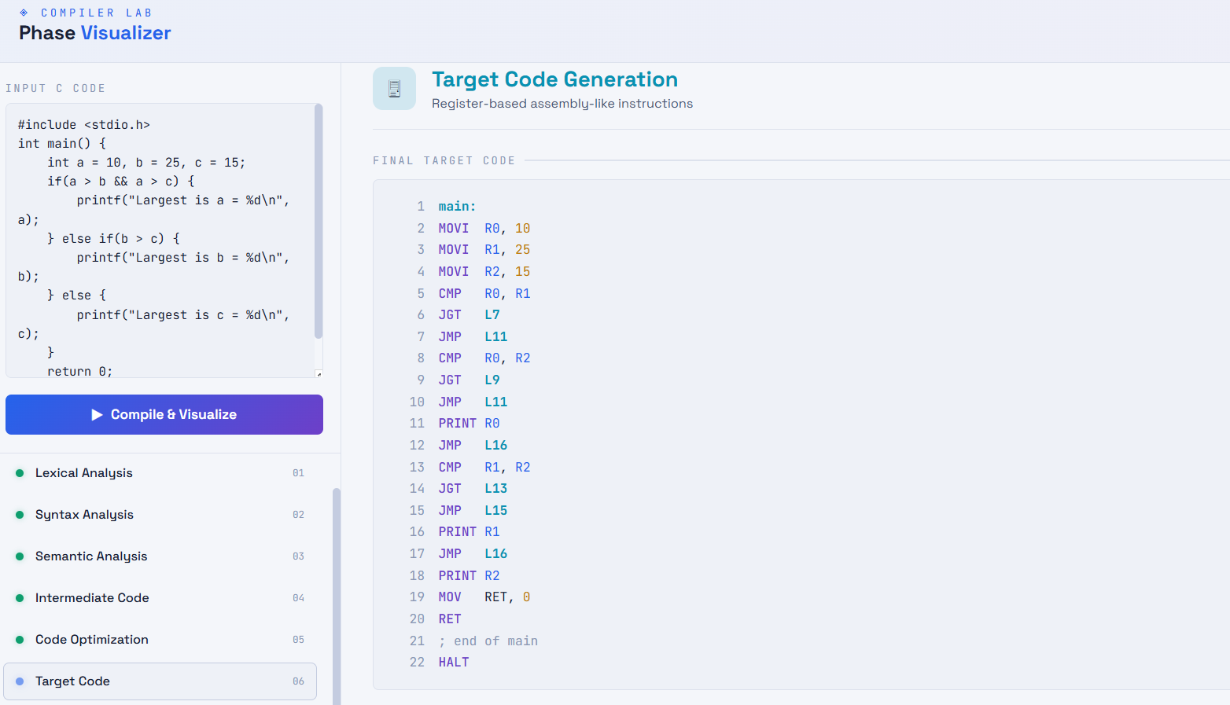

Test Case4:Nested If else

